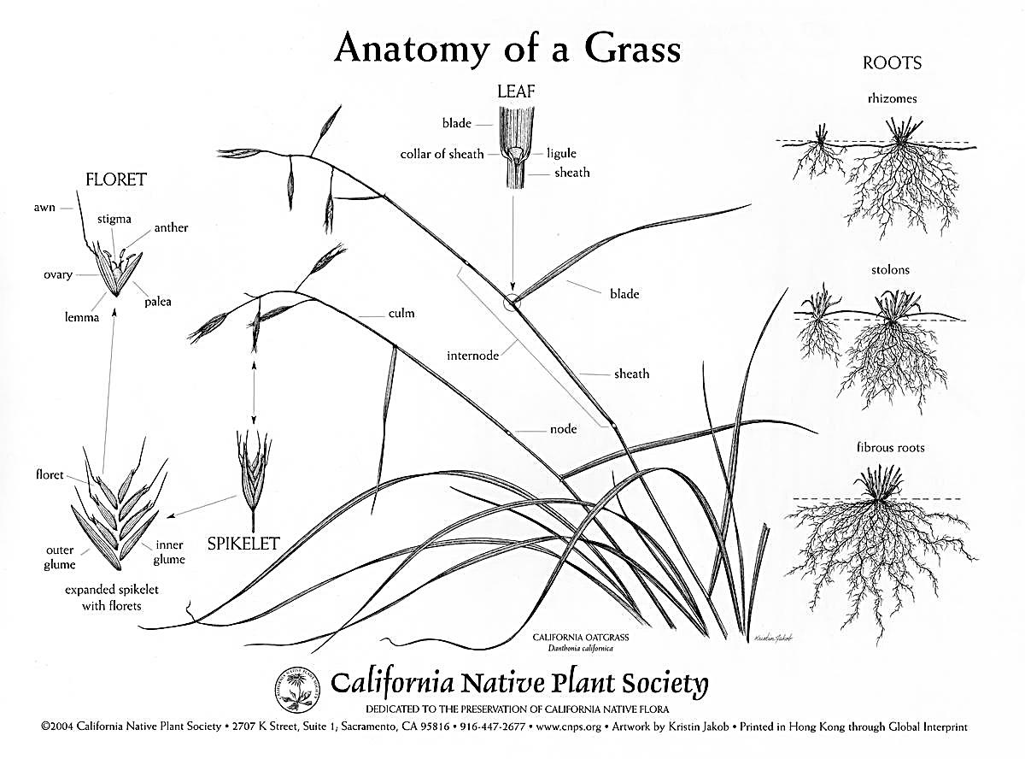

**Floret**- Individual flowers bracted by a lemma and palea

**Spikelet**- The basic unit of a grass inflorescence consisting of 2 glumes and 2 or more florets

**Glumes**- A pair of bracts at the base of a spikelet

**Awn**- A bristle-like appendage, usually a continuation of the mid-nerve of the lemma or the glume

**Culm**- A grass stem, usually hollow except at the ordinarily swollen nodes

**Node**- The joint of a culm (the “knees” of a grass stem)

**Internode**- The culm (stem) segment between two nodes

**Blade**- The laterally expanded portion of a grass leaf

**Sheath**- The basal portion of the leaf that surrounds a grass stem

**Leaf**- The sheath and blade of a grass

**Collar**- The outer side of a grass leaf at the junction of the sheath and blade, often lighter colored than the surrounding tissue

**Stolon**- Stems that lie upon the ground and root at the nodes or at least bend over and root at the tip

**Rhizome**- A creeping underground stem

**Fibrous**- A type of root form

**Ligule**- An outgrowth from the leaf sheath. Because they vary in size, shape, and texture, they are used in the identification process

**Lemma**- The lower of two bracts surrounding the grass flower (see palea)

**Palea**- The uppermost of two bracts surrounding the grass flower (see lemma)

**Anatomy of a Grass**

|  |  |  |  |  |  |  |  |  |  |  |  |  |  |  |  |
| --- | --- | --- | --- | --- | --- | --- | --- | --- | --- | --- | --- | --- | --- | --- | --- |
|  |  |  |  |  |  |  |  |  | 1 |  |  |  |  |  |  |
|  |  |  |  |  | 2 |  |  |  |  |  |  |  |  |  | **Word Bank**  rhizome  stolon  fibrous  culm  spikelet  palea  lemma  ligule  floret  glumes  leaf  node  blade  collar  internode  sheath  awn |
|  |  |  |  |  |  |  |  | 3 |  |  |  |  |  |  |  |
|  |  |  |  |  |  |  |  |  |  |  |  |  |  |  |  |
|  |  |  |  |  | 4 |  |  |  |  |  |  |  |  |  |  |
|  |  |  |  |  |  |  |  |  |  |  |  | 5 |  |  |  |
|  |  |  |  |  |  |  |  |  |  | 6 |  | 7 |  |  |  |
| 8 |  |  |  |  | 9 |  |  |  |  |  |  |  |  |  |  |
|  |  | 10 |  |  |  |  |  |  |  |  |  |  |  | 11 |  |
| 12 |  |  |  |  | 13 |  |  |  |  |  |  |  |  |  |  |
|  |  |  |  |  | 14 |  |  |  |  |  |  |  |  |  |  |
|  | 15 |  |  |  |  |  |  |  |  |  |  |  |  |  |  |
|  |  |  |  |  |  |  |  |  |  |  |  |  |  |  |  |
|  |  |  |  |  |  |  |  |  |  | 16 |  |  | 17 |  |  |
|  |  |  |  |  |  |  |  |  |  |  |  |  |  |  |  |
|  |  |  |  |  |  |  |  |  |  |  |  |  |  |  |  |

**Down**

1. Stems that lie upon the ground and root at the nodes or at least bend over and root at the tip

2. A type of root form

5. The culm (stem) segment between two nodes

6. A pair of bracts at the base of a spikelet

8. A grass stem, usually hollow except at the ordinarily swollen nodes

10. The uppermost of two bracts surrounding the grass flower (see lemma)

11. Individual flowers bracted by a lemma and palea

13. The laterally expanded portion of a grass leaf

17. A bristle-like appendage, usually a continuation of the mid-nerve of the lemma or the glume

**Across**

3. The outer side of a grass leaf at the junction of the sheath and blade, often lighter colored than the surrounding tissue

4. A creeping underground stem

7. The joint of a culm (the “knees” of a grass stem)

9. The basic unit of a grass inflorescence consisting of 2 glumes and 2 or more florets

12. The sheath and blade of a grass

14. An outgrowth from the leaf sheath. Because they vary in size, shape, and texture, they are used in the identification process

15. The lower of two bracts surrounding the grass flower (see palea)

16. The basal portion of the leaf that surrounds a grass stem